|  |  |  |  |  |  |
| --- | --- | --- | --- | --- | --- |
| **CONTENT** | | |  |  |  |
| 1. Introduction | |  |  |  | 2 |
| 1.1. Purpose | |  |  |  | 2 |
| 1.2. Scope | |  |  |  | 2 |
| 1.3. Overall Scope | | |  |  | 3 |
| 2. USE CASE & ACTION DIAGRAM | | |  |  | 4 |
| 2.1. Use Case | | |  |  | 4 |
| 2.2. Action Diagram | | | |  | 5 |
| 3. DECOMPOSITION DESCRIPTION | | | |  | 6 |
| 3.1 Entity Relationship Diagram (ERD) | | | |  | 6 |
| 3.2. Data Decomposition | | | |  | 6 |
| 4. DETAILED DESIGN | |  |  |  | 7 |
| 4.1 Entire Menu 7 | | | | | |
| 4.1.1 API List | | | |  | 8 |
| 4.1.2 Screen Design | | |  |  | 9 |
| 5. INTEGRATION REQUIREMENT | | |  |  | 11 |
| 5.1 Introduction | | | |  | 11 |
| 5.2 Terms and Definition | | | |  | 11 |
| 5.3 Package and Dependencies | | | | | 13 |
| *Appendix A* |  |  |  |  | 12 |

1. **INTRODUCTION**

This Software Design Document (SDD) outlines the technical design and development of PISM Donation System application that enables individual and organization to make donations to Pusat Islam Sultan Mahmud Universiti Malaysia Terengganu.The App is design to be user friendly and easy to navigate with a streamlined donation process that minimize the number of step required to complete a donation.The SDD will cover the App’s layout,functionality and integration with rest of the donation system.The main target users of the system will be the general public.This document covers the purpose,scope and SDD document introduction.

**1.1 Purpose**

The purpose of this document is to show how the system will be structured to meet the requirement.It translate the requirement into a description of the software structure,software components,interface,and data required in the implementation phase.Design description is used to present a system that can be explained as a group of design entities,each possessing properties and relationship.To summarize the model properties and relationships for each design entity are described by a standard set of attributes. A design description is complete when all attributes have been identified for all entities.In a complete SDD, each requirement must be traceable to one or more design entities.

In conclusion,the SDD is to be the clear and detailed representation of the overall blueprint for the implementation activities.it’s a valuable document that helps to keep project organized and final product to meet the requirement.

**1.2 Scope**

The PISM donation App and will be deployed online on the internet and intranet through a secure network.This app will be used by UMT staff,UMT student and the public general.In this document,the system will cover modules such as the list below

**1.3 Overall Scope**

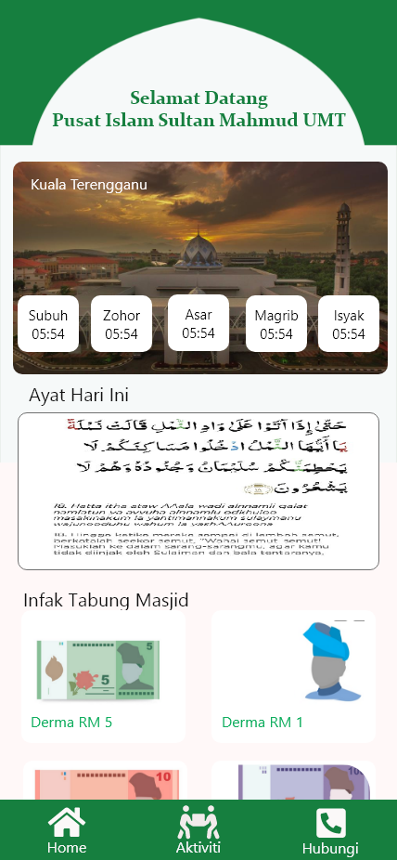

1. Home

2. Contact

3. Activities

**2.0 USE CASE & ACTION DIAGRAM**

**2.1 USE CASE**

users

View PISM planned activities

View Prayer Time

View Ayat AL-Quran

View PISM contact information

Donate to PISM

**2.2 ACTION DIAGRAM**

|  |  |  |
| --- | --- | --- |
| **Timeline** | **Peranan** | **Aktiviti** |
|  | * Users | Donate to PISM |
| * Users | View Ayat Al-Quran |
| * Users | View Prayer Time |
| * Users | View PISM Planned Activities |
| * Users | View PISM Contact Information |
| * Users | Access Bank |

**3.0 DECOMPOSITION DESCRIPTION**

**3.1 Entity Relationship Diagram (ERD)**

Refer to ***Appendix A***

**3.2** **Data Decomposition**

This section shows all the table for the module

|  |  |
| --- | --- |
| **Table Name** | **Module** |
| PISM_DERMA | PISM Donation App |

1. **Table Name** : PISM_DERMA

**Description** : Table used to store Derma information of user

|  |  |  |  |
| --- | --- | --- | --- |
| **Column Name** | **Column Type** | **Width** | **Description** |
| ID_DERMA | NUMBER |  | ID for every row |
| DERMA_DATE | DATE |  | Date of the donations |
| JENIS_INFAK | VARCHAR2 | 255 | Category of the infak |
| TOTAL | NUMBER | 10 | Total of the donations |
| ID_INFAK | NUMBER |  | ID of the infak |
| NAMA_PENDERMA | VARCHAR2 | 255 | Name of the users |
| PHONE_NO | VARCHAR2 | 50 | The users phone number |
| PHONE_MODEL | VARCHAR2 | 255 | The model of the users phone |
| PHONE_MANUFACTURE | VARCHAR2 | 255 | The manufacturer of the users phone |
| PHONE_OS | VARCHAR2 | 255 | The operating system of the users phone |
| BANK NAME | VARCHAR2 | 255 | Name of the bank |
| BANK_DATE | DATE |  | Date of the payment |
| STATUS_TRANSAKSI | VARCHAR2 | 20 | The status of the transaction |

**Trigger** : None

**4. DETAILED DESIGN**

This section contains the detailed internal design of entity.It explains interface design,report design,processing and data.

**4.1 Main Menu**



**4.1.1 API LIST**

|  |  |  |
| --- | --- | --- |
| **API** | **SCREEN** | **DESCRIPTION** |
| JAKIM Waktu solat | Home.dart | Shows prayer time base on location of the user |
| AL-Quran | Home.dart | Show different ayat Al-Quran each day |
| Derma Admin Web | Home.dart | Show Infak that admin has add from the web |
| Google Map | Contact.dart | Show Location of PISM |
| PISM | Activities.dart | Show PISM planned activities |

|  |  |
| --- | --- |
| Menu ID : | Homepage.dart |
| SDK: | '>=2.17.0 <3.0.0' |
| Version: | 1.0.0+1 |
| API Level : | 31 |
| Description : | Module that is used by Users |

|  |  |
| --- | --- |
| Menu Name : | HomePage |
| Description : | Menu that is Used by Users |
| Sub-menu : | * Home [homepage.dart] * Aktiviti [Aktivti.dart] * Hubungi [Contact.datr] |

**4.1.2 Screen Design**

**Screen ID :** home_page.dart

**Description :** view Al-quran,prayer time and donate to PISM

**User :** Users

**Screen:**



**Screen ID :** aktiviti.dart

**Description:** View activities planned by PISM

**Users :** Users

**Screen:**

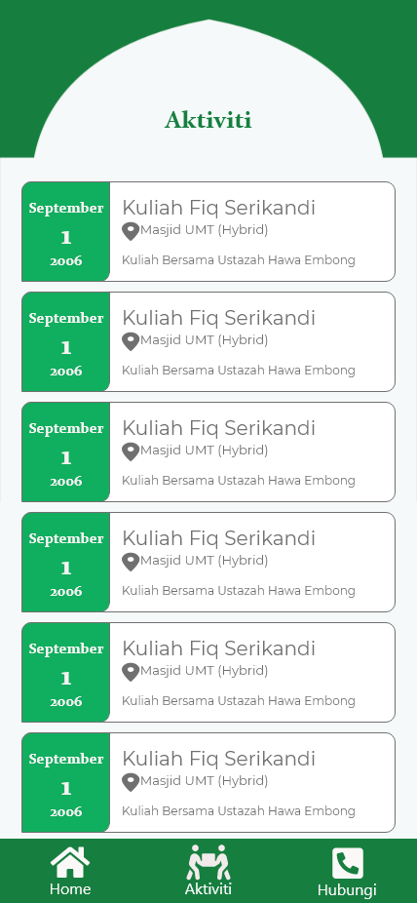

**Screen ID :** Contact.dart

**Description:** View PISM contact information

**User:** Admin.

**Screen:**

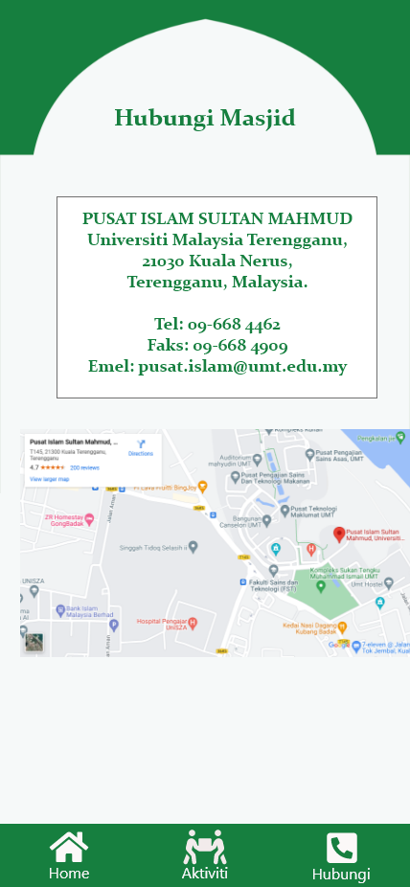

**5. INTERGRATION NEEDS**

This chapter explains the overall integration architecture,integration methods and types of feedback such as errors and related notifications.It also explains the integration requirement,the definition method used in the documentation and the general rules used.

**5.1 Introduction**

As mentioned above,this chapter describes the integration architecture.In addition,the integration will implement the request-reply method.However,the Web Page Document Module does not have the concept of data integration because it is only a stand alone module.

**5.2 Terms and Definition**

The following states the terms and definition in this chapter:

* (Method) – Exchange data between system and covers online and in stages(batch)
* Target or source – location of the originated data.
* Data Out – data sent to another system or application that requested the data
* Data In – relevant data requested by the system
* Mode – Type of data that is transferred in parallel (synchronous) or not (asynchronous) only one way at a time
* Errors – errors or disturbance that causes system malfunction
* Notification – a notice generated by integration process that informs the users about something happening

**5.3 Package and Dependencies**

|  |  |
| --- | --- |
| **Bil** | **Dependencies** |
| 1 | cupertino_icons: ^1.0.2 |
| 2 | http: ^0.13.5 |
| 3 | flutter_phone_direct_caller: ^2.1.0 |
| 4 | url_launcher: ^6.0.17 |
| 5 | flutter_lints: ^2.0.0 |

**Appendix A**

(Entity Relationship Diagram - ERD)

|  |  |
| --- | --- |
| PISM_ADMIN | |
| **PK** | **ID_ADMIN** |
|  | EMAIL  PASSWORD  NAME |

|  |  |
| --- | --- |
| PISM_DERMA | |
| **PK**  **FK1**  **FK2** | **ID_DERMA**  **JENIS_INFAK**  **ID_INFAK** |
|  | DERMA_DATE  TOTAL  NAMA_PENDERMA  PHONE_NO  PHONE_MODEL  PHONE_MANUDACTURE  PHONE_OS  BANK_NAME  BANK_DATE  STATUS_TRANSAKSI |

|  |  |
| --- | --- |
| PISM_INFAK | |
| **PK**  **FK** | **ID_INFAK**  **JENIS_INFAK** |
|  | IMAGE  TOTAL  DESCRIPTION  NAMA_INFAK |

|  |  |
| --- | --- |
| JENIS_INFAK | |
| **PK** | **JENIS_INFAK** |
|  | NAMA_INFAK |